HW- 1

Your task is to create a home page for yourself (Task A and Task B)
Do not use any web page authoring tools.
You may use text editors like Notepad++, Notepad, TextEdit, etc.
But we recommend you use VS Code.
Download Visual Studio Code - Mac, Linux, WindowsLinks to an external site.

[
VS Code can be used to write code in other programming languages also (for example, Java, Python, and etc. – you may need to install appropriate extensions. View these videos, https://code.visualstudio.com/docs/getstarted/introvideos
]
Create and preview your first web page in VS Code (youtube.com)
https://code.visualstudio.com/docs/languages/html
You may install appropriate extensions later. Click on marketplace icon (or ctrl+sht+X) and search on ‘HTML’ (later we will also use CSS, JS, and PHP). Do some research to find suitable extensions. New extensions may be included.
Check Prettier, Live Server, Auto rename tag, HTML/CSS Support, CSS Peek, ESLint, JS ES6 snippets, etc
Top 30 VS Code Extensions for Enhanced Programming - Kinsta®Links to an external site.
(later) PHP Programming with Visual Studio CodeLinks to an external site.

You should use HTML5 for content display. You may use CSS3 (inline, embedded or external) for formatting.
IMPORTANT: You should not use any deprecated tags (e.g. <center>, <font> ), attributes (<… align=”right” bgcolor=”red” > , or properties ( < …….border =”5”). If you use, -5 points will be added for each such usage.
HTML Help:
https://www.w3schools.com/html/default.asp https://www.w3schools.com/html/html5_intro.asp
Create and preview your first web page in VS Code - YouTube
https://www.w3schools.com/html/html_editors.asp
https://openclassrooms.com/en/courses/2479876-build-your-website-with-html5-and-css3/2490098-your-first-web-page-in-html

Task A: (20 * 3 = 60 points)
In this part, you will create a web page similar to the web page in the image below. It includes a heading, an image (centered), a horizontal divider, sub headings, paragraphs, lists, hyperlinks to other page, book marks, etc,

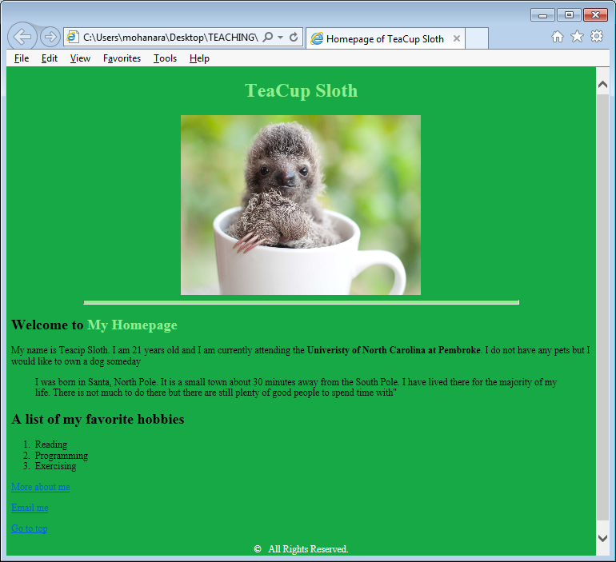

[Instead of VS code, If you plan to use Notepad++, download and Install from https://notepad-plus-plus.org/ ; alternatively, you may also use Notepad, TextEdit, or any other text editor that you prefer]
Open VS Code (or other text editors)
Create a folder HW1.
Create a new file and save the new file as HTML type- name it as HW1solution1.html.
[in notepad++, save as- select type, and save with the file name HW1solution1 (.html will be added)
Type the minimal HTML-5 code (see the box below) in HW1solution1.html.
The shorthand boilerplate in Visual Studio Code (! and tab) is a quick way to generate the basic structure of an HTML document. Type ! and then press the Tab key. This will automatically generate the HTML boilerplate code for you(may be slightly different from the code in the box below).
Remove all [ ]s and their contents, and include your content.
<!DOCTYPE html>
<html>
<head>
<meta charset="UTF-8">
<title> [Title of the document] </title>
[the rest in the head section, if any]
</head>
<body>
[the content of the document......]
</body>
</html>
[thanks:]

Write HTML-5 code for the following.
- Set the title of the window to "Homepage of (your full name)".
- Include your first and last names as meta keywords [will not be displayed on web page].
- Set the background color of the page (e.g. yellow)
[don’t use bgcolor attribute; instead use <body style= “background-color: ??”>

- VERY IMPORTANT: Include the following comment just after the tag <body>. Comments in HTML should be included between <!-- and -->. Comments will not be displayed when the page is rendered on the browser.
<!-- this page is created by [include your name here] on [include the date here] -->
- Type your name as level-1 heading and align it to center (don’t use <center>, use style = “ “ ) and set the text color (e.g. blue).
Periodically, save your html file, and test on a browser. To test in Notepad++; menu bar; RUN → Launch in <your browser>
If you are using VSCode and if you don't have the Live Server extension installed, you can install it from the Extensions view by searching for "Live Server" and clicking the install button. Right-click on your html file in the Explorer view and select Open with Live Server.
Alternatively, you can open the html file directly in your web browser by navigating to the file location (hw1 folder) and double-clicking it.
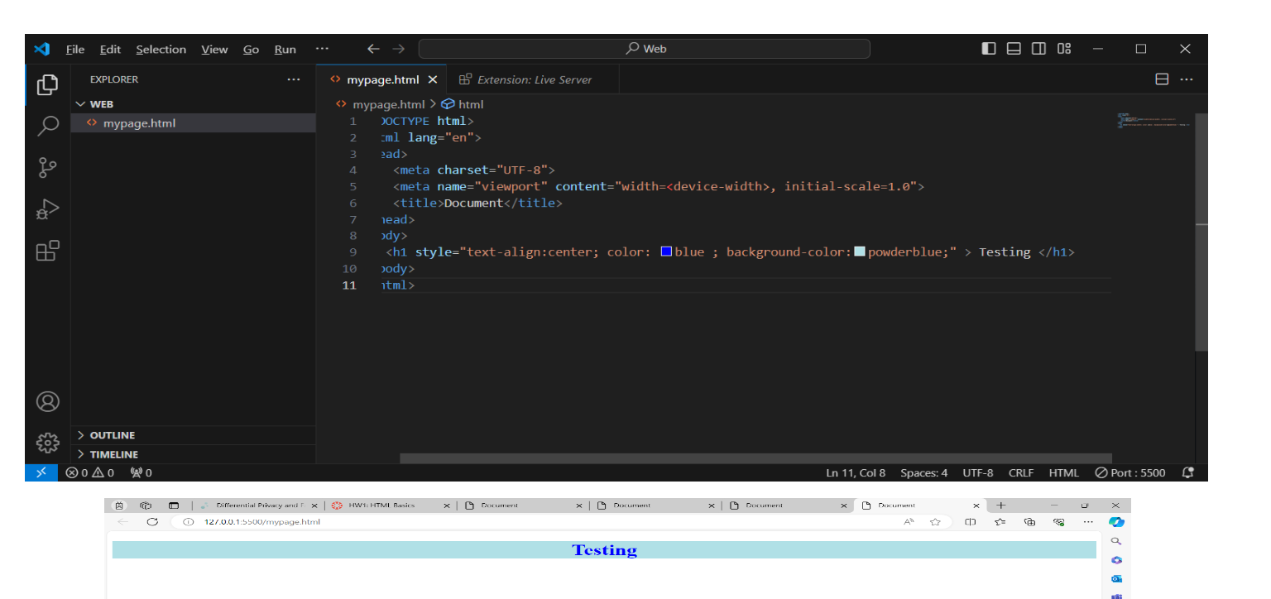
- Include an id for the above heading. This bookmark id will be used later in task 14.
- Include an image (may be your image) below the heading with appropriate width and height (avoid distorting your image), and align the image to center. Give suitable ALT text.
- Include a horizontal line (with 75% width and 6px height, and set background-color) below your image.
- Include a level-2 heading “Welcome to My Home Page” after the horizontal line.
- Use SPAN element to set different color to the part of the above heading “My Homepage”
- Include a paragraph (more than three sentences about yourself). Use at least one in-line logical tag (such as em, strong, q, etc..) appropriately.
- Include another paragraph about your hometown and highlight it using ‘blockquote’.
- Include an ordered list that gives your hobbies/interests (3-5 items).
- Include a hyper link on appropriate text (may be “Goto Top”), and when clicked on this hyper link the top part of the page should be displayed [use the bookmark id crated in task 6]. Check
https://www.w3schools.com/TAgs/tryit.asp?filename=tryhtml5_a_href_anchor
- Include a hyper-link on appropriate text (may be “Email Me”), and when clicked on this hypertext the default email program should be launched. Check https://www.w3schools.com/TAgs/tryit.asp?filename=tryhtml_link_mailto
- Include Line Breaks in appropriate places (if necessary).
- Include a hyper-link on the text “more about me”, when clicked it should open another web page (will be created in task B)
- Include a footer section.
- Inside the footer include a copyright statement with symbol ©. Save your html file.
- Validate your html file (you may use validator.w3.org). Make appropriate corrections, and validate again. Save your html file.

Task B: (11 * 3 = 33 points)
In this task, you will create a web page similar to the image in next page.

Create a new HTML file. Save the new HTML file using the file name HW1solution2. html
Include the minimal HTML-5 code given in part-1 in HW1solution2.html.
- Include a suitable title (may be “My Education History”).
- VERY IMPORTANT: Include the following comment just after the tag <body>. Comments in HTML should be included between <!-- and -->. Comments will not be displayed when the page is rendered on the browser.
<!-- this page is created by [include your name here] on [include the date here] -->
- Include a level-1 heading (may be “My Education History”).
- Create a table with the caption “My Education”.
- Table has two columns with headings School and Period. Fill in 2-3 rows with suitable information.
- In the last row, merge both columns and include the text “I am at UNCP now”.
- After the table, include a paragraph about UNCP as a pre-formatted text.
- Include a hyper-link for the UNCP site with suitable hypertext.
- Include an iFrame (use height = 150 and width = 300) that displays a youtube video about UNCP
[search for uncp youtube in google. Or type the following url https://www.youtube.com/watch?v=M_GfOPDR-ac
Right-click on video and click on copy embed code; on your html document paste this code at appropriate location. Edit the height and width, etc..]
check https://www.w3schools.com/html/html_youtube.asp

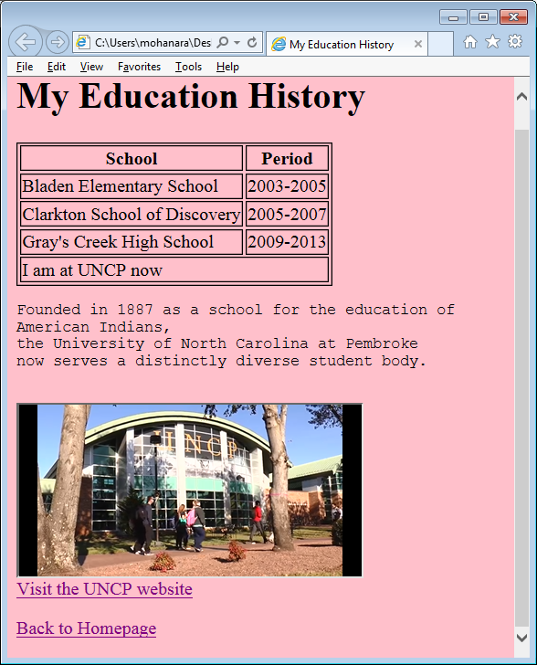

- Include the attribute ‘sandbox’ to iFrame. Set autoplay on for the video (you need to allowscripts and allowsameorigin- but anyway, note that this is not a good practice).
Check https://www.html5rocks.com/en/tutorials/security/sandboxed-iframes/
- Include a hyper-link to get back to your home page in Task A.
Save your html files. Preview Your Web Page:
If you are using VSCode and if you don't have the Live Server extension installed, you can install it from the Extensions view by searching for "Live Server" and clicking the install button. Right-click on your html file in the Explorer view and select Open with Live Server.
Alternatively, you can open the html file directly in your web browser by navigating to the file location (hw1 folder) and double-clicking it.
If you use notepad++, RUN → Launch in ??
Validate both of your html files and make appropriate corrections.

Take snap-shots of validation pages of both final html documents

Take snap-shots of both web pages.

Submit via Canvas. [ 7 points for overall submission]

You have to zip the following files before submitting;
html files (2),
external css files (if any),
image (1),
screenshots of web pages (2), and
screenshots of validation results(2)

